Annexure-VI
Increase in productivity and impact in farmers in the form of Success Stories published in APR (2017-18)

A. Laser land Levelling: An Opportunity for Entrepreneurship
Ambala is the North-Western district of Haryana with 1.55 lakh ha geographical area and 1.35 lakh ha net cultivated area. Moreover, the net irrigated area of Ambala is approximately 1.10 lakh ha, out of which 85 % and 15 % is being irrigated by tubewells and canals respectively. The average annual rainfall of the Ambala district is 1076 mm, which is mainly received in monsoon season (July-September). Rice-wheat is the dominant cropping system, while sugarcane is also the major cash crop of Ambala. In Ambala, rice is grown over 0.83 lakh ha area and average productivity is about 38 qtl/ha, which is largely grown by manual transplanting of seedlings into puddled soils. Whereas wheat is cultivated on the 0.86 lakh ha area and its productivity is 46 qtl/ha. Sugarcane is on the other hand is cultivated on the 0.10 lakh ha.
The water use for rice has been reported as 1560 mm in Haryana. Due to increased use of groundwater, the reports shown that during year 1974-1994 the average annual decline in water table was 234 mm per year. Out of six blocks in Ambala, the three blocks i.e. Saha, Naraingarh and Barara are overexploited the groundwater resources, by which they are considered as dark zone. Therefore, the increasing water scarcity threatens the productivity and sustainability of the irrigated rice-wheat system in Haryana in general and Ambala in particular. Researchers have observed that due to poor water management and uneven fields 10-25 percent of irrigation water has been lost. It remain stagnates at low spots or going as deep percolation losses.
Since we are working on the several resources conservation technologies (RCT’s) such as direct seeded rice (DSR) in rice, zero-tillage (ZT) in wheat and paired row technology in sugarcane for resource conservation. But without precise land leveling we could not reap the real benefits of resource conservation technologies. Because the excess water stagnation due to uneven fields not only delays the tillage operations but also has a major impact on the germination, crop stand and yield of crops. Traditionally levelled fields have uneven crop stand and uneven maturing of the crops. Traditional methods are time consuming also lack in precise grade.
KVK Intervention
Keeping in view the primary benefit of a reduction in the loss of irrigation water occurring due to highly undulating land and energy saving trough reduced duration of irrigation, the Krishi Vigyan Kendra (KVK), Tepla-Ambala initiated the adoption of laser land levelling as a part of the resource conservation technology since 2009. During the year 2009 to till date, we have conducted several the FLDs, OFTs, Trainings, Travelling Seminar & Publications, news coverage’s, exhibitions were done to popularize RCTs and we emphasized the benefits of laser land levelling technology.
For the dissemination & horizontal expansion of the technology, we have imparted one extension functionaries training during the season in each year since 2010. The field staff of different agricultural departments such as PACL Company, Department of Agriculture, Assistant agricultural engineering, Cooperative societies, were trained on different aspects of resource conservation technologies. They were trained and familiarized with different aspects of these RCTs right from the laser land levelling of the field, seed drill calibration, treatment of seeds, method and time of sowing and nutrient, irrigation & weed management etc.
As the KVK, Tepla is working collaboratively with CSISA/CIMMYT on the front of Resource Conservation Technology. Therefore, time to time, the interested farmers from Ambala district were sent to see the trial and research sites of the CSISA. By organizing such kind of exposure visit/travelling seminar, the farmers believe by seeing & learn by interacting with the farmers. The KVK published a pamphlet titled “Sanshadhan Sarankshan Taknikya” and were distributed to the farmers.
During this extension work on adoption of resource conservation technology in Ambala district, one farmer Sh. Vikram Singh S/O Sh. Sukhminder Singh from Mullana, who has not only adopted direct seeded rice technology, but also he has purchased his own laser land leveller during 2010-11. Through KVK extension work, he was made aware about the importance of laser land levelling in agriculture such as water saving, increase in yield, saving in energy etc. He has only 8 acre of land and therefore he motivated to work as a entrepreneur by running the laser land leveller on custom hiring basis. Then he has purchased the laser land Leveller from Karnal worth Rs. 3,10,000.00 in year 2011. The average number of hours (600 per year) he worked during the very short spell of only 60 days in a year and amount (Rs./h, 610) on custom hiring basis he charged from the service providers (Table 1).
Table 1. Running hours and cost of custom hiring
Year | Hours/year | Rs/h
2011-12 | 510 | 550
2012-13 | 610 | 575
2013-14 | 680 | 600
2014-15 | 660 | 625
2015-16 | 580 | 650
2016-17 | 550 | 650
Avg | 598 | 608

Cost of operation
The cost per hour operation of the machine is calculated by summing up the fixed costs, operating costs and labour costs. The fixed cost includes equipment depreciation, interest on investment, taxes/insurance and storage. However, in this study, the tractor’s fixed cost was not taken in to consideration. Operating costs were evaluated on the basis of cost of fuel, lubricant, tyres and equipment maintenance and repairs. Labour costs were estimated on the basis of Rs. 10000 per month and daily use of 8 hours of day. The data in table 2 reveal that the per hour cost of laser land levelling is 455/h.
Table 2. Cost evaluation of laser land levelling
Item | Tractor | laser equipment | leveller
Initial cost (A) | - | 200000 | 100000
Economic life (B) | - | 15 years or 15000 h | 15 years or 18000 h
Salvage value (C) | - | 10% A= 20000 | 15% A=15000
Depreciation (D) | - | (200000-20000)/  15000=12.0 | (100000-15000)/  18000=4.7
Interest (E) | - | 9.0 | 4.3
Taxes/Insurance (F) | - | 4.5 | 2.1
Storage (G) | - | 7.5 | 3.5
Fixed cost (H)= (D+E+F+G) | - | 36.0 | 14.6
Fuel (I) | 275 | - | -
Lubricant (J) | 27.5 | - | -
Servicing and repair (K) | 40.0 | 15.0 | 5.7
Labour (L) | 42.0 | - | -
Variable cost (M)= (I+J+K+L) | 384.5 | 15.0 | 5.7
Total cost (N)= (H+M) | 384.5 | 51.0 | 20.3
Grand total (Rs./h) = (C1+C2+C3) | 455.8 or say 455

Economic analysis
For the data presented in table 2, the various financial parameters were derived in table 3. The data reveal that the he has a financially visible scheme in laser land levelling with a benefit cost ratio of 1.55, payback period of less than 3 years, NPW (Net present Worth) of Rs. 1033431, While the average use of laser land leveller is 600 h per year and average charges of Rs 610 per hour on the custom hiring basis. He earned Rs. 105000 average annual benefit by running the laser land leveller on custom hiring basis for around 60 days working during summer season after harvesting of the wheat.

Table 3. Cash flow of laser land leveller (Rs.)
Years | Total investment (Rs.) | Discount factors | Annual cost (Rs.) | Total cost (Rs.) | Discounted cost (Rs.) | Gross income (Rs.) | Discounted benefits (Rs.) | Benefits (Rs.)
1 | 2 | 3 | 4 | 5 (2+4) | 6 (5*3) | 7 | 8 (7*3) | 9
0 | 300000 | 1.0000 | 273000 | 573000 | 573000 | 366000 | 366000 | -207000
1 | 0 | 0.9259 | 300300 | 300300 | 278048 | 402600 | 372767 | 102300
2 | 0 | 0.8573 | 330330 | 330330 | 283192 | 442860 | 379664 | 112530
3 | 0 | 0.7938 | 363363 | 363363 | 288438 | 487146 | 386696 | 123783
4 | 0 | 0.7350 | 399699 | 399699 | 293779 | 535860 | 393857 | 136161
5 | 0 | 0.6806 | 439669 | 439669 | 299239 | 589446 | 401177 | 149777
6 | 0 | 0.6302 | 483635 | 483635 | 304787 | 648390 | 408615 | 164755
7 | 0 | 0.5835 | 531998 | 531998 | 310421 | 713229 | 416169 | 181231
8 | 0 | 0.5403 | 585198 | 585198 | 316182 | 784552 | 423893 | 199354
9 | 0 | 0.5002 | 643718 | 643718 | 2947085 | 863007 | 431676 | 219289
Total |  |  |  |  | 2947085 |  | 3980516
B:C ratio = 1.55
Payback period = < 3 years, NPW = 1033431
Key assumption: Interests @ 8 % with a grace period of 1 year; costs and service charges increase @ 10 % per annum

Output
Realizing the potential of the CA based management systems in water depleting area of Ambala, systematic work on resource conservation technologies (RCTs) was initiated jointly by KVK Ambala, deptt. of agriculture and CSISA program, which was run jointly by IRRI and CIMMYT. RCTs are a vital part of sustainable Agriculture which is the topic of common debate among the scientists & policy makers. While we organized the technology week in our KVK, several laser land leveller manufacturers approached us for putting up the stall for demonstration purposes. Sustainable Agriculture is the demand of today & tomorrow (i.e. future year). In brief, no sustainable agriculture, no future of ours.

Outcome and impact
The joint work on the RCTs has resulted in that the farmers have understood possible benefits of laser land levelling in Ambala district. By which several young farmers were came into the laser land levelling and they not only done the work on their own farm but also they have also employed one unemployed rural youth on his technology to earn the profits. Nearly 35-40% of net cultivated area has been levelled by around 135 number of laser land levellers in Ambala. The rural youth who had adopted this technology for self and custom hiring system, they are the direct number of beneficiaries. But indirectly, for the repair and maintenance of laser land leveller two times more number of unemployed rural youth was benefited.
According to researches, in Haryana, the average reduction in timing of irrigation for rice and wheat crop is 72 hour/hectare in case of fields are laser land levelled. The average size of tubewell motor in Ambala is 25 B.H.P and they require 20 KWh of energy per operational hour. Thus the electricity saving is about 1440 KWh per hectare for rice and wheat crop. By considering the average value of each KWh to Rs. 5, the monetary value of saved electricity in the rice-wheat system of production in a hectare of a laser levelled field as compared to the traditionally levelled field is equivalent to about USD 150 per year. It states that conservation of energy is the generation of the energy and this is reason for which KVK is emphasizing the benefits of this role model technology i.e. Laser Land Levelling.

Table 4. Estimated achievement of laser land levelling in Ambala, district, Haryana
 | Financial years
 | 2011-12 | 2012-13 | 2013-14 | 2014-15 | 2015-16
No. of machinesª | 8 | 22 | 55 | 81 | 135
Gross area levelled (hectares)^{b} | 1920 | 5280 | 13200 | 19440 | 32400
Net area levelled (hectares)^{c} | 1920 | 5280 | 13200 | 18320 | 27370
Notes
a-cumulative number of machines operating in the district (survey based)
b-levelling capacity assuming 240 ha/machine/annum
c-Net levelling capacity assuming fields re levelled every three year (survey based)

Scope
Still 60-65 % of the net cultivated area in Ambala is not levelled through laser land Leveller. Moreover around 17000-21000ha area needs re-levelled every year. So there is a opportunity for the unemployed farm youth for have this technology and work on the custom hiring basis. The KVK has been playing the role through extension system i.e. awareness on adoption of resource conservation technologies, by which more number of farm youth will have the benefited. On the other hand the day by day depleting groundwater resources can also be saved and the crop yields can also be increased.

Benefits of the laser land levelling
Following are the possible benefits of effective laser land levelling technology:
- This technology facilitates technology smart agriculture.
- Level/graded and smooth soil surface results in more uniform distribution of water by which normally it can save 30 % water.
- Enable to use on comparatively larger field sizes and increases the farm area between 3 to 5 %, besides it reduces the operating time by 10-15 percent.
- More uniform moisture in root zone of the crops resulting in better germination, growth and also increases the rate of utilization of fertilizer to 20 percent.
- Increase production: Every unit area increases the production by 20% to 30%.
- Decrease cost: Using the technology could decrease the production cost of rice and wheat.

Needs
Since farmers are already convinced of its financial viability. Institutional support would be the key role for its horizontal expansion. Therefore financial support to the farmers through machine banks (Self help groups, SHGs) must reach to the door steps of the farming community. Which can accelerates the growth of mechanization and also helps to fulfil the dream of our Honourable Prime Minister Sh. Narender Modi Ji to double the farm income by year 2022.

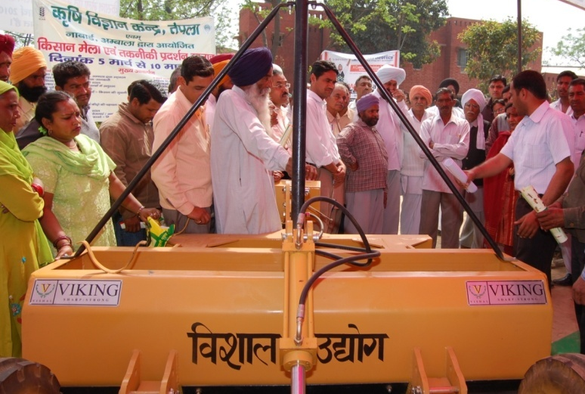
Demonstration of laser land leveller at KVK during technology Week in year 2010

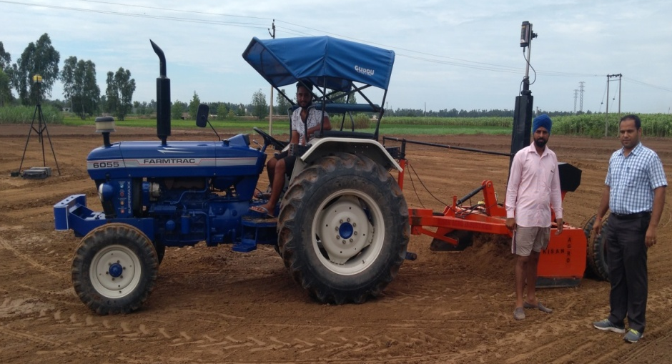
Demonstration of laser land leveller at farmer’s field

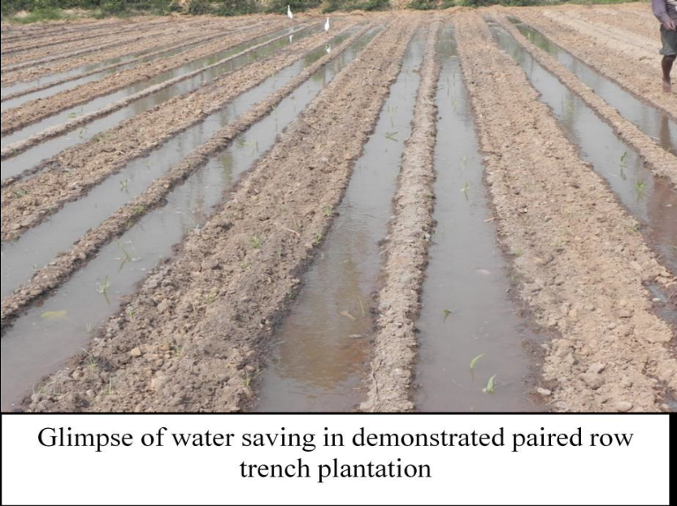
Glimpse on water saving in sugarcane under paired row ridge and furrow plantation method at KVK farm

- Summer Mungbean
Case Study
Introduction-: Mungbean or green gram which is commonly known as Moong is an important pulse crop grown in our country and accounts 11% to the total production of pulses. Mungbean is generally short duration crop compared to other pulses and is easily accommodated in most of the crop rotations which provide a small nitche between two major crops during Summer or Kharif. Mungbean is delicious pulse and is considered as first choice among pulses particularly in northern parts of the country. Green gram is generally recommended by doctors for growing children, old persons, patients due to its easy digestibility. Eating mungbean sprouts is indeed a very important part of healthy eating. In India green gram (mungbean) occupies 3.0 million ha. And contribute to 1.3 million tones in pulse production. It is grown in our country during Kharif. But it is also grown in spring or summer season in irrigated northern plains and as a rabi crop in southern & south-eastern parts, where the winter is quite mild. Mungbean is also used a green manuring crop. Being a leguminous crop it has the capacity to fix atmospheric nitrogen. It also helps in preventing soil erosion. Mungbean is considered to be the hardest of all pulse crops.
On account of mungbean short duration, photo-insetivity and also dense crop canopy, it assumes special significance in crop intensification and diversification, conservation of natural resources and sustainability of production system. Therefore, it is considered as an excellent intercrop, catch crop, cover crop and also soil fertility restorer.

A. KVK Intervention-:
KVK Ambala conducted FLDs, OFTs, trainings and organized Field Days to popularize Mungbean
cultivation in Ambala district during the last twelve years and their details are given below-:

- Front Line Demonstrations :
Table 1: Popularization of Mungbean cultivation through FLDs
Crop season | Village | Area (ha.) | No. of Demon  strations | Variety | Local Check | Yield (Qt/ha.) |  | % increase in yield
 |  |  |  |  |  | Demo. | Local Check | % increase in yield
Summer 2006 | Chudiala | 2 | 5 | SML-668 | Pusa Vishal | 5.75 | 4.37 | 31.00
Summer 2007 | Chudiala & Harda | 2 | 5 | SML-668 | Asha | 8.00 | 6.16 | 29.87
Summer 2008 | Haldari | 2 | 5 | SML-668 | Asha | 5.31 | 4.37 | 21.14
Summer 2009 | Baragarh | 2 | 5 | SML-668 | Asha | 14.95 | 11.67 | 28.10
Summer 2010 | Kesri, Langar Chhanni & Naggal | 4 | 10 | SML-668 | K-851 | 10.50 | 9.20 | 14.13
Summer 2011 | Teja Mohri, Majri & Mardon Sahib | 8.4 | 21 | SML-668 | K-851 | 8.75 | 7.00 | 25.00
Summer 2012 | -- | 6.8 | 17 | SML-668 | K-851 | 5.95 | 4.35 | 36.78
Summer 2015-16 | Allahpur,Bahrog, Chudiala,Dhamoli,  Tobba,Gadauli,Gheldi, Nagla, Ghasitpur,  Jawahargarh,Magar-pura,Kotkachua,  Pilkhani | 47.2 | 118 | M.H.421 | SML-668 | 8.97 | 7.0 | 28.24
Summer 2016-17 | Pilkhani,Haldari, Tepla  Samlehri,Landa, Khudda Kalan, Langar Channi, Gheldi,Harda, Bihta, Nagla Jattan, Shahpur,Jawahargarh | 20 | 50 | SML-832 | SML-668 | 8.24 | 6.0 | 37
Summer 2017-18 | Uplana,Thakurpura,Tobba,Samlehri,Rachheri,Nanhera,Gadauli,Khojkipur,Jawahargarh,Rampur,Budha Kheda, Akbarpur ,Jeolly,Tepla | 30 | 75 | M.H.421 | SML-668 | R.A. | R.A. | R.A.

Photographs
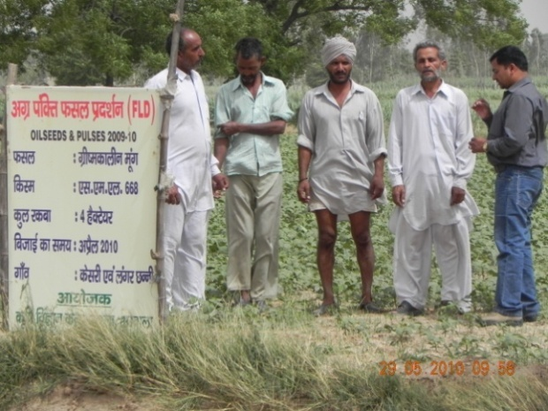 | 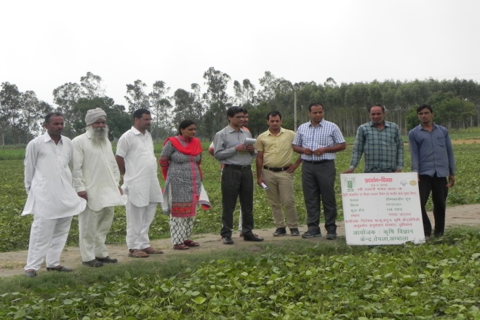
Field visit at Moong plot | Scientists team visited at Mungbean FLD plot (2015-16)
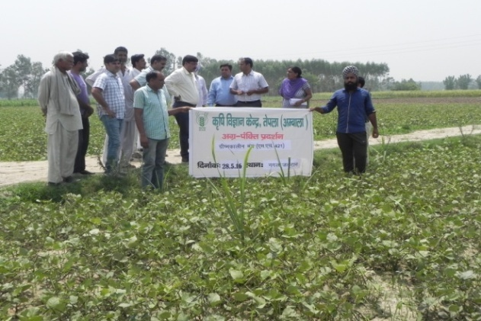 | 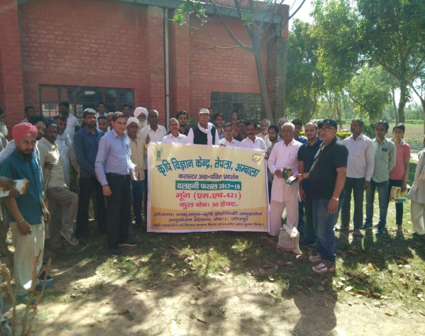
Mungbean Plot visited by Dr. Rajbir Singh,  Director, ATARI, Zone-I, Ludhiana | Input distribution of Moong(2017-18)

Table 2: Economic analysis of FLDs on Summer Mungbean
Crop Season | Cost of cultivation (Rs/ha.) |  | Gross return (Rs/ha) |  | Net Return (Rs/ha.) |  | B:C Ratio
Crop Season | Demon. | Local Check | Demon. | Local Check | Demon. | Local Check | Demon. | Local Check
Summer 2006 | 4798 | 4062 | 18400 | 13984 | 13602 | 9022 | 3.83 | 2.81
Summer 2007 | 6710 | 6788 | 20000 | 15400 | 13290 | 8612 | 2.98 | 2.26
Summer 2008 | 3125 | 2925 | 11682 | 9614 | 8557 | 6689 | 3.73 | 3.28
Summer 2009 | 8182 | 8234 | 32890 | 25674 | 24708 | 17440 | 5.41 | 5.19
Summer 2010 | 8854 | 9068 | 38850 | 34040 | 29996 | 24972 | 4.38 | 3.75
Summer 2011 | 8375 | 8525 | 30625 | 24500 | 22250 | 15975 | 3.65 | 2.87
Summer 2012 | 5000 | 4250 | 18445 | 13485 | 13445 | 9235 | 3.69 | --
Summer 2016 | 16250 | 15200 | 58305 | 45500 | 42055 | 30300 | 3.59 | 3.0
Summer 2017 | 16400 | 14700 | 43054 | 21350 | 26654 | 16650 | 2.6 | 1.9
Summer 2018 | R.A. | R.A. | R.A. | R.A. | R.A. | R.A. | R.A. | R.A.

- On Farm Trials
Problem diagnosed | Title of OFT | No.of trials | Technology Assessed | Production per unit/  qtl/ ha | Net return (Profit) in Rs./ha | BC Ratio
2008-09
Use of Desi variety instead of improved variety | Varietal Evaluation of Summer Moong variety SML-668 in Ambala | 5 | Sapna  ML-267  SML-668 | 11.67  13.25  15.0 | 15,674-00  19,150-00  23,000-00 | 1.56  1.91  2.30
2011-12
Residue burning of wheat,deterioration in soil physical properties and low organic matter | Performance evaluation of different cultivation method of summer-moong | 3 | T₁ - Conventional tillage + Broad Casting -F.P.  T₂ - Reduced tillage + Line sowing (HAU, Hisar) –Ass.  T₃ - Zero Tillage Sowing – Ass. | 2.62  2.95  2.13 | 2825  3999  2125 | 1.15  1.80  1.15
2012-13
Un-awareness about new variety of Summer Moong(SML-832) | Varietal Evaluation of Summer Moong (SML-832) | 3 | T₁ - SML-668 -F.P.  T₂ - SML-668 -PAU- Rec.  T₃ - SML-832-(PAU)-Ass. | 5.47  5.70  6.37 | 12181  13115  15604 | 3.07  3.30  3.88
2015-16
- Low yield  - Deterioration in soil properties  - Low organic carbon | Introduction of Summer Mungbean MH-421 to get higher yield and improve soil health | 3 | T₁ - Basanti (F.P.)  T₂ – SML-668 (PAU) –Rec.  T₃ - MH-421 (CCSHAU)-Ass

III. Training Programmes & Extension Activities :
- Trainings & Field Days
Year | No. of Trainings | No. of Participants | Field Days
Year | For Farmers | For Farmers | No. | Participants
2006 | 2 | 39 | 1 | 35
2007 | 1 | 9 | 1 | 45
2008 | 1 | 25 | 1 | 37
2009 | 1 | 10 | 1 | 35
2010 | 3 | 51 | 1 | 40
2011 | 2 | 40 | 1 | 34
2012 | 2 | 32 | 1 | 24
2013 | 2 | 29 | 1 | 25
2014 | 2 | 28 | -- | --
2015 | 1 | 14 | -- | --
2016 | 3 | 160 | 2 | 61
2017 | 2 | 46 | 1 | 25
2018 | 1 | 70 | -- | --

Photographs
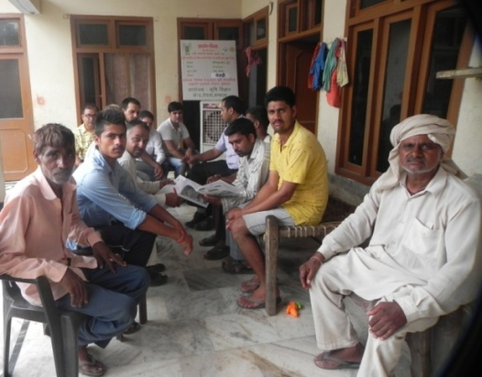 | 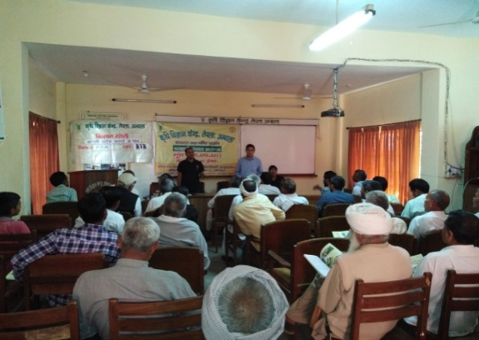
Krishak Gosthi(2016) | Krishak Gosthi (2018)
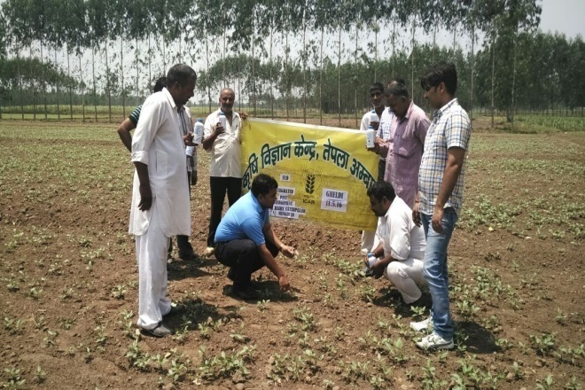 | 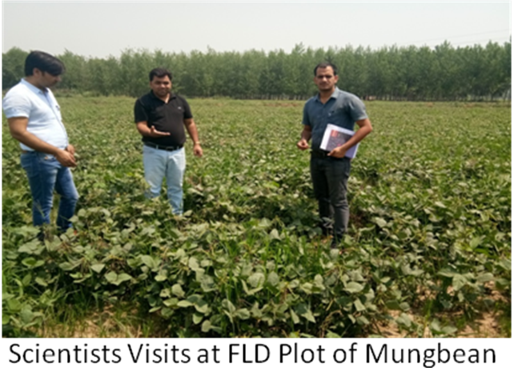
Diagnostic services on mungbean plot | Diagnostic services on mungbean plot
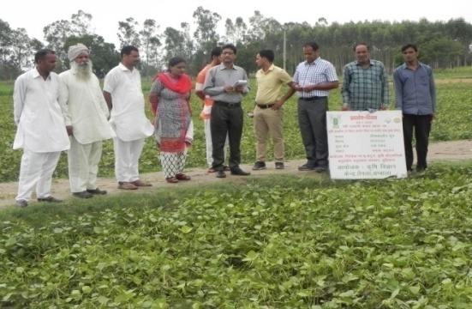 | 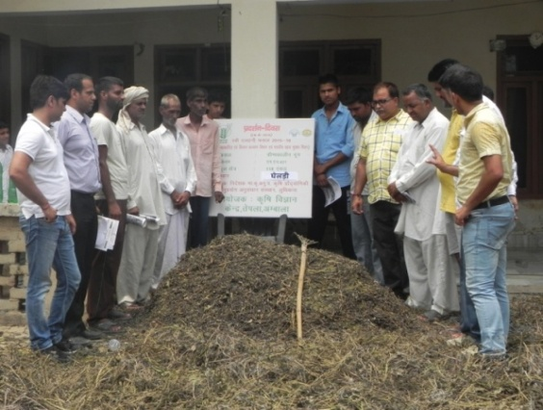
Field Day (2016) | Field Day on Summer Moong

- Workshop/Training Programmes attended by KVK Scientists :
- Zonal Workshop (1-2 December,2015) at Directorate of Extension, CCSHAU,Hisar : Attended by
Dr.Upasana Singh, PC & Dr.Rakesh Choudhary, SMS (Agro), KVK,Ambala

- Mid-term Review Meeting on Cluster FLD on Pulses at KVK,Kaithal (12th July,2016) :Report presented
by Dr.Upasana Singh, PC & attended by Dr.Rakesh Choudhary,SMS(Agro.),KVK,Ambala

- Workshop on Cluster FLD on Pulses(23.1.2017) attended by Dr.Rakesh Choudhary,SMS Agronomy and
report presented at ATARI-Zone-I,Ludhiana.

- Two days Sensitization Workshop-cum-Training programme (pulse crops) (30-31st October,2017) at ICAR-ATARI, Jodhpur attended and report presented by Dr.Rakesh Choudhary, SMS (Agronomy)

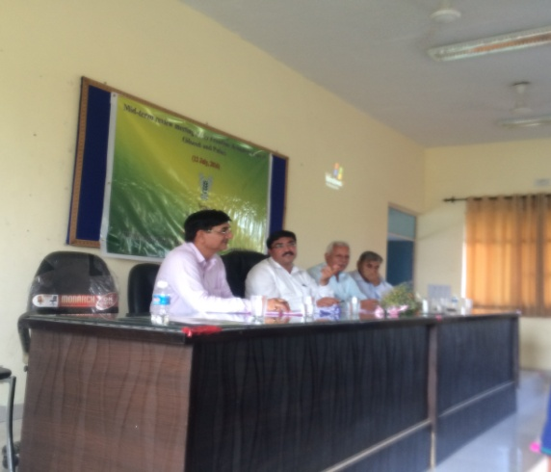 | 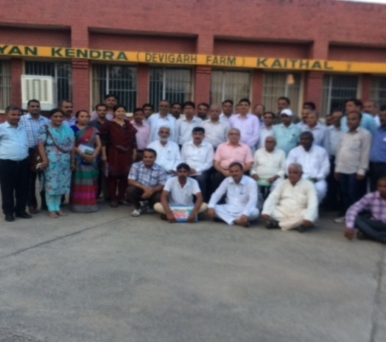
Mid-term Review Meeting on Cluster FLD on Pulses at KVK,Kaithal(2015-16)
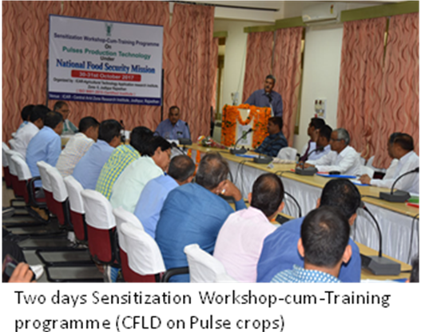
Two days Sensitization Workshop-cum-Training programme (CFLD on Pulse Crops) ATARI,
Zone-II, Jodhpur (2017-18)

C. Delegates Visits :
Dr.Rajbir Singh, ICAR-ATARI,Zone-I,PAU,Ludhiana
Dr. Mahesh Kumar, Deputy Director, Wheat Development Centre, Gaziabad
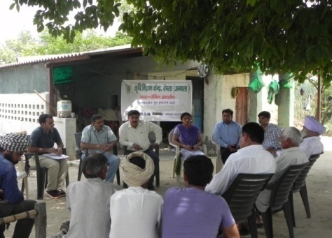 | 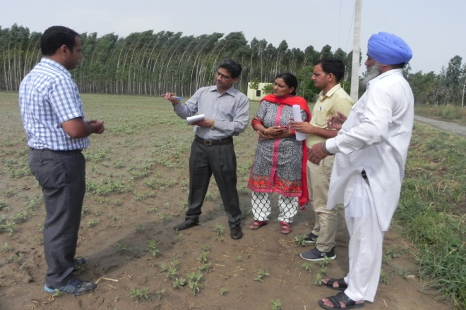
Dr.Rajbir Singh, Director, ICAR-ATARI,Zone-I | Dr. Mahesh Kumar, Deputy Director,  Deputy Director, WDC,Gaziabad

D. Literature/Research Paper Published & Developed :
- Summer Moong Compiled Data : “Summer Mungbean Intensification” (Zonal Project Directorate, Zone-I, Ludhiana) in year 2010
- Research Paper : Boosting summer mungbean production through frontline demonstration AFZAL AHMAD, RAMESH KUMAR AND GURU PREM Agriculture Update A, Volume 7 , Issue 1 & 2 , February & May, 2012,| 122-125
- Extension Bulletin :
- Moong Ki Vagyanik Kheti : KVK,Ambala (2015-16)
- Dalhani evm tilhani fasalo ki vagyanik kheti (2017-18)
- Posters
- Dalhani Faslo ki Nayi Taknik : KVK,Ambala (2015-16)
- Diversify of crop rotation through intensification of summer mungbean in Rice-Wheat cropping system in
Ambala
- Handouts : Moong Dal ke Papad v wadia (Hindi) (2016)
- Krishi Vigyan Patrika (Quarterly Magazine ) : Kab Kaya Karen (Moongbean), Plant protection measures (Moongbean)
- Mobile Message Circulation : Related to Moongbean (1200 farmers) (2015-16,2016-17 & 2017-18))
- News in various newspapers (2006-2018)
- Video film (Success)
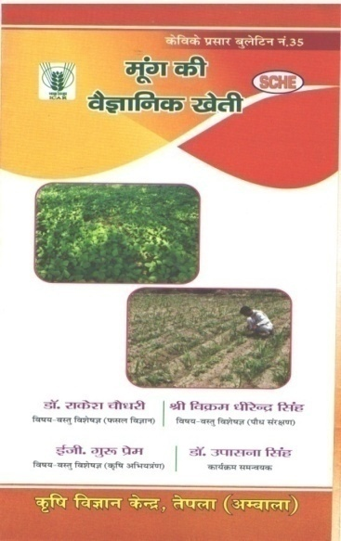 | 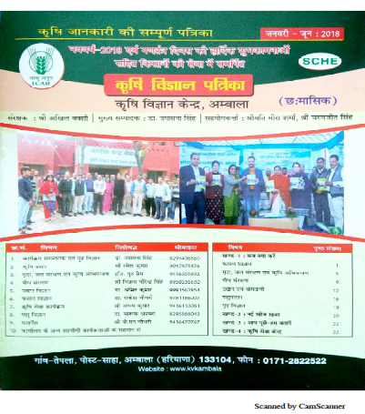
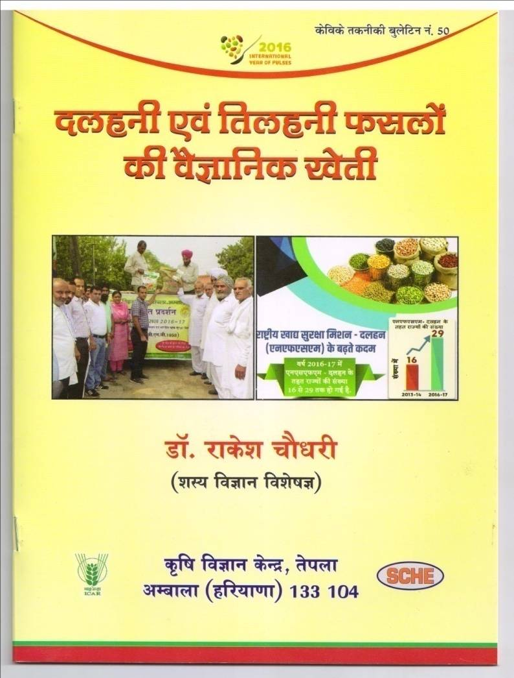 | 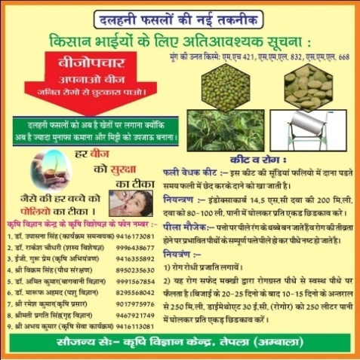
Publication (Mungbean)
E. Success Story :

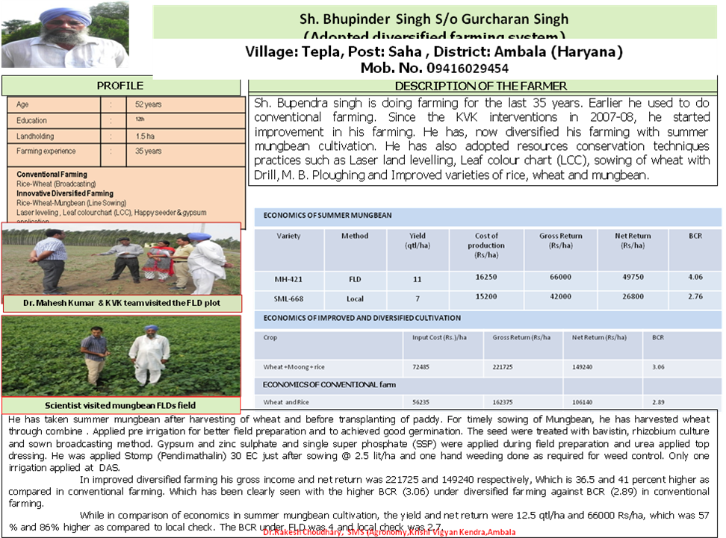

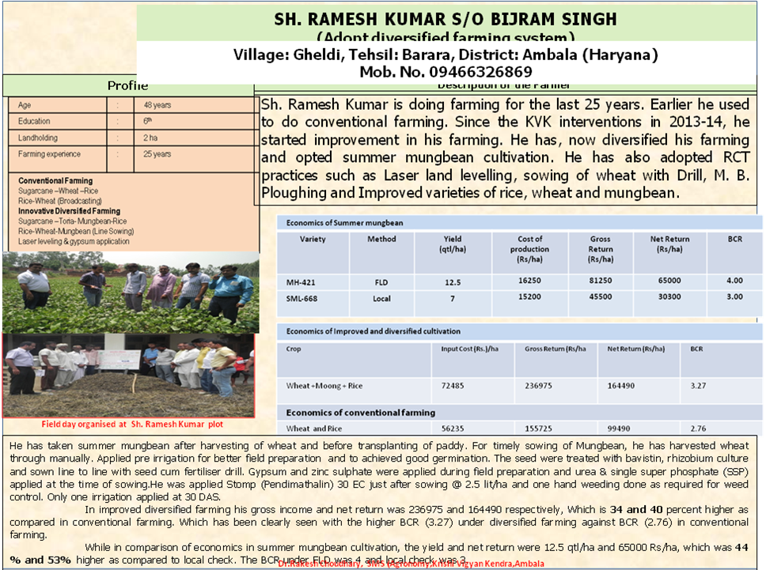

- Output-:
Due to combined efforts of KVK & Agriculture department of Haryana Government, the area under Summer Moong has increased 1000 ha. (year 2006-2018) in Ambala district and productivity has increased (approximately 8.97 qt/ha. in 2016).

- Outcome-:
Promotion of summer moongbean has resulted into eschew of Sathi Rice cultivation by the farmers & cultivation of Summer Moong in place of Sathi Rice. This practice led to elimination of excessive water exploitation by the farmers as Sathi Rice was transplanted in middle of April and harvested in June. At this time, there was excessive summer heat and a lot of water was required to grow Sathi Rice. Moreover, there was no rainfall during that period as monsoon period normally starts after mid June in Haryana and this resulted in tremendous load on water use. Underground water table depleted very fast and Sahazadpur, Saha & Barara blocks of Ambala district were declared under dark zone. Government banned the sowing of rice before 15th May and transplanting of rice before 15th June. To void this gap, Sathi Moong (Summer Moong) was promoted by KVK & Agriculture Department of Haryana.
Another advantage of Summer Moong cultivation is that besides, providing pulses, it also helps in improvement of soil health & fertility as it fixes atmospheric nitrogen from the atmosphere and adds Nitrogen to the soil. It also helps in improvement of organic carbon level of soil if it is incorporated into soil after harvesting of pulses. The beneficial effect of Summer Moong in between the rice & wheat crops has been observed in enhanced productivity of rice and wheat crops. By growing Summer Mungbean in the gap of wheat & rice, the grain yield of basmati rice increased to the tune of 11 % in comparison to rice-wheat crop rotation devoid of summer mungbean. The effect of summer summer mungbean was noticed in wheat also grown after basmati rice and the wheat productivity increased by 4 % under Summer Mungbean basmati rice wheat cropping sequence.
The variety SML-668 grown during summer season has the characteristics of synchronous maturity (80-90%), the farmers prefer the picking of pods as and when mature. The picking of pods is generally done by hired labour and consequently employment is provided to landless labour during lean months of summer season.

Value Addition :
Pulses called as wonder food as they are low in fat and absorb the flavor of spices and herbs, making them fun & tasty to eat. People has been eating pulses for thousands of year and these foods are the main source of protein in many cultivar all over the world. Beans & legumes have all the nutrients that are now important in preventing heart disease, caner and obesity.
For vegetarian, pulses are a vital part of life and for non-vegetarians pulses offer an alternative source of protein without fat with lot of fiber. The old saying “Dal-Roti” is the combination of pulses and cereals providing balanced food in terms of nutrition.
Mungbean is delicious pulse and is considered as first choice among pulses particularly in northern parts of the country. It is being recommended by doctors for growing children, old persons and patients due to its easy digestibility.: Sprouted Mungbean is very nutritive and delicious as half cut sprouted seed provided vitamin C equalent to six glasses of juice. Therefore a plateful of sprouted moong chat & salads is a tasty and healthy way of getting daily dose of vitamin. Mungbean is also good source of proteins, thiamin, iron, magnesium, phosphorus, potassium etc.
Keeping in mind the liking and nutritive value of Mungbean, KVK Ambala had conducted various awareness programmes in schools, aanganwadies and rural areas regarding low cost Moong Dal .
S.No. | Events | Venue | Dated | Participants
1 | Nutrition Week | - Aanganwadi : Saha  Dheen(Sansad Village )  Rampur Chapra | 10.8.2012  7-9-2015  3-9-2016 | 50  38  25
1 | Nutrition Week | - Schools : Saha &  - Tepla | 10-9-2012  7-9-2016 | 50  116
1 | Nutrition Week | - Health Centre :Bihta | 7.9.17 | 30
2 | Training & OFT : Moongdal Papad & Wadia | SHG , Naraingarh Block (Ahmadpur) | 7-6-2016 | 30
2 | Training & OFT : Moongdal Papad & Wadia | KVK | 24-4-2017 | 17
3 | World Food Day | Phulelmajra | 17-10-16 | 40
3 | World Food Day | KVK, Campus | 12.10.17 &  15.10.17 | 100

OFT & Trainings (Wadia & Papad of Mungbean) (SHG & Farm Women)
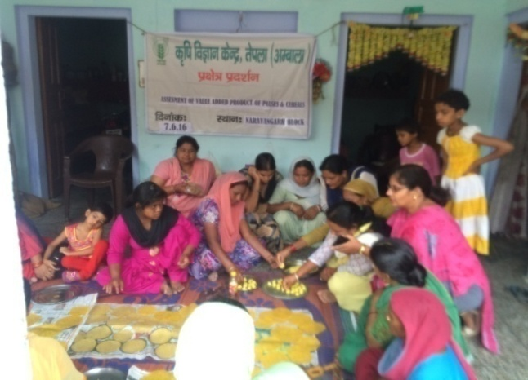 |  | 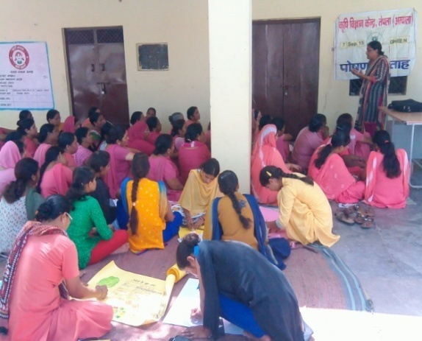
Village Ahmadpur |  | Nutrition Week (Village Dheen)
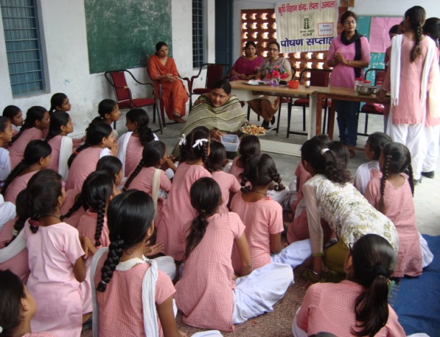 |  | 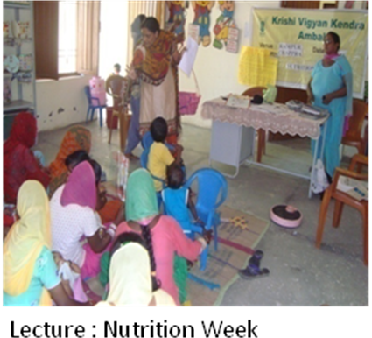
Nutrition Week (Village Saha) |  | Nutrition Week (Villag Rampur)
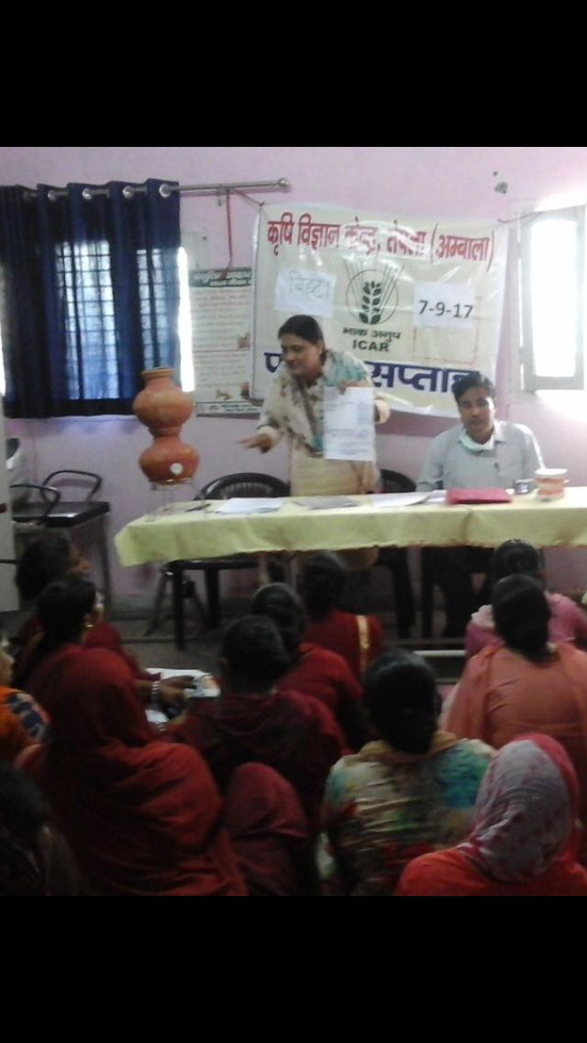 |  | 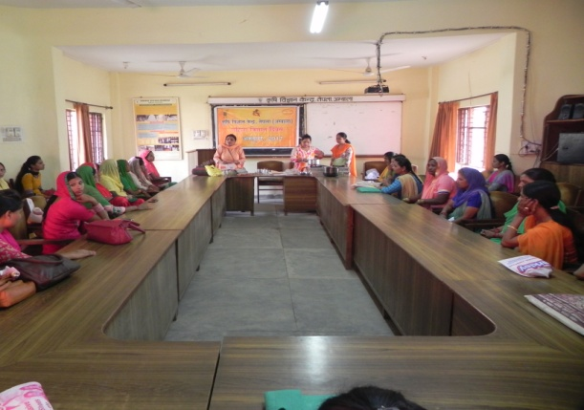
Nutrition Week (Village Bihta) |  | KVK Campus
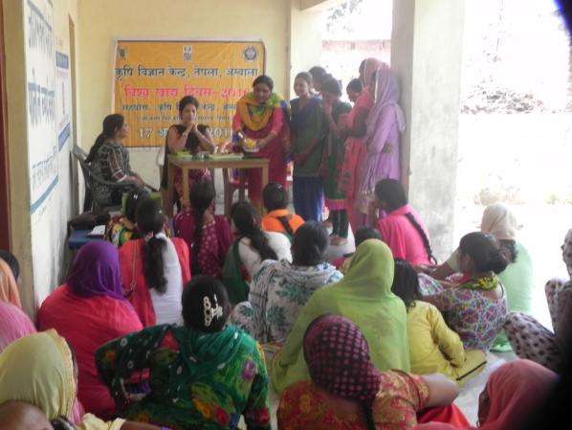 | 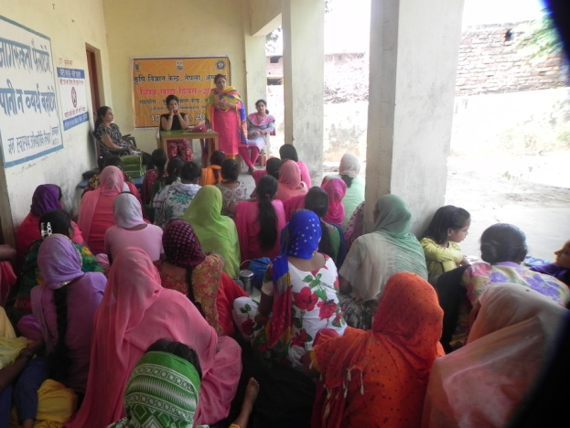
World Food Day (Village Phulelmajra) | World Food Day (Village Phulelmajra)

D. Impact-:
- Extension/ horizontal spread of area. 1000 ha (2006 to till date) in Ambala district
- Improves soil fertility as Mungbean is used as green manuring crop.
- Enhances productivity of Rice & Wheat Crops if Mungbean is incorporated in between rice & wheat.
- Higher yield & increased B:C Ratio over local check proves that Mungbean Cultivation is economically viable enterprise.
- Mungbean is also used as intercrop with Sugarcane and Poplar.
E. Future Approach :

The Director, ICAR-ATARI,Zone-II,Jodhpur approved Front Line Demonstrations on Pulse crops (2017-18) on 30 ha under NFSM.
Adoption of the technology in a big way proved an eco-friendly alternate to summer rice in order to conserve the underground water resources improves soil fertility, increase pulse production, employment to landless labourer and above all improves nutritional status of family as well.

- Success (Other Enterprises ) : Pig Farming

Self employment through Pig Farming: A success story of Mr Ranjod Singh


Name : Sh.Ranjod Singh

Village : Lohgarh,

District : Ambala- 134003(Hry.)

Mob.No. : 7988003657

Introduction: India posses 10.29 million pig population which share 7% of the total meat production in the country. The total number of pig in Haryana state as per census 2012 is 0.13 million number. Pig production is an important secondary occupation for livelihood and nutritional security of the rural people. In India, potential for piggery as business opportunity has not yet been fully realized. With the increasing pressure on land, pig rearing could offer economic, food and social security to the resource poor families. Piggery is the most potential source of meat production and more efficient feed converter after the broiler. Apart from providing meat, pig is also a source of bristles and manure.
Background and problems: Mr Ranjod Singh, 28 years old, graduates in B. Tech. from Lauhgarh village of district Ambala, Haryana. After graduation he took up a job in a private sector and simultaneously studied for competitive exams, only to struggle for the next two years without any success. He then decided to start his own business. Mr Ranjod Singh rightly contracted to KVK tepla for training on commercial pig farming in 2016. After training he constructed a pig farm in 2400 square feet area in Lauhgarh village. KVK scientist fully supported during construction of house, purchase and selection of animals and KVK itself provided 10 pure Large White Yorkshire piglets for his farm. Presently, he is maintaining 25 sows, 20 gilts and 2 boars along with piglets at his farm. He also developed a IFS unit Pig-cum fish farming at his farm. The cost of fish feed reduced by the use of pig dung in the pond. Due to high cost of feed, the pigs are being maintained on kitchen waste, vegetable (cauliflower, carrot, potato etc.) and sugarcane press mud (Maili/jugary) during the seasons.
Output: The out puts of entrepreneur are the production of piglets, gilts, boars and manure along with fish from IFS unit.
Outcome: he earned a rich dividend from sale of piglets and gilts as a record; he earned a net profit of Rs 5.15 lakhs in a year 2016-17 and Rs 45,000 and Rs 5,000 from sale fish and pig manure, respectively. This success achieved distinctly over a short period of time. Mr. Singh has also developed and loaded a video of his farm on you tube.
Impact: The development of the pig farming system model by Mr. Ranjod Singh has not only been beneficial to him in terms of livelihood but it has also influenced other unemployed rural youths of the neighboring areas to seriously think about this profitable proposition. His ventures promoted economic stability and sustainability and are an example for locals to emulate. "By starting his own business he is not only earns for him but gave employment to other poor family. In fact this will also keep them away from anti-social activities and help in creating a stable society and ultimately contribute to the development of the state.

Details of farm and profit in 2016-17

Particulars | Number
Sow | 25
Gilt | 20
Boar | 2
Piglets | 60
Income (Rs)
Expenditure on feed, vaccine, medicine etc. | 2,92,000
Sale of piglets (323) @Rs 2500 | 8,07,500
Sale of manure | 5,000
Sale of fish | 45,000
Total income | 8,57,500
Net Income | 5,65,500

Outer view of Pig Farm

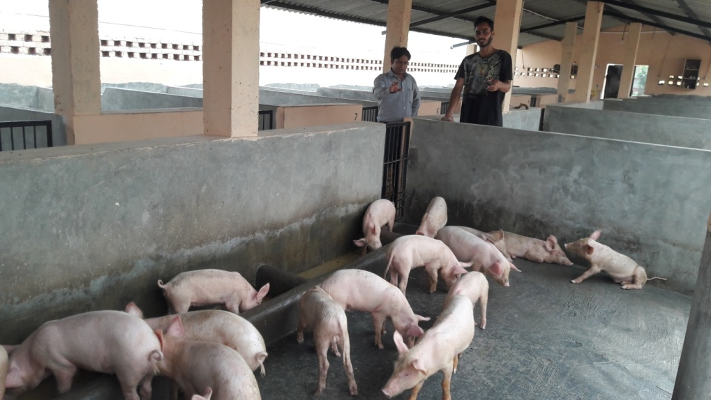
Inner view of the pig farm
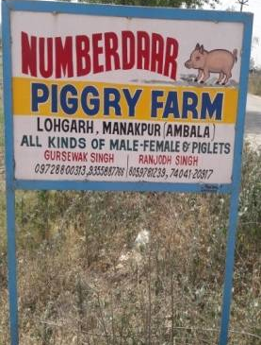
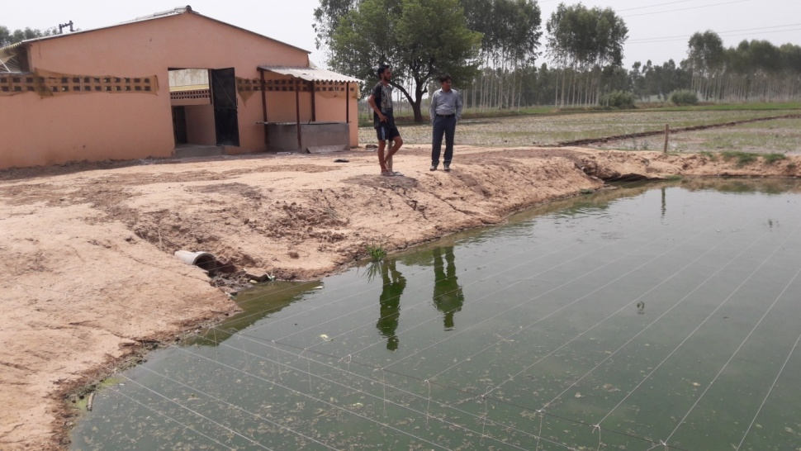
IFS (Pig cum fish farming)

IV. Women Empowerment : A success of Sarpanch Mrs.Sumneet Kaur

